**<>**

**Data Specification**

Version <>

# Revision History

|  |  |  |  |
| --- | --- | --- | --- |
| Date | Version | Description | Author |
| <MM/DD/YYYY> | <version> | <description> | <author> |
|  |  |  |  |
|  |  |  |  |

# Table of Contents

Revision History 2

Table of Contents 3

Introduction 4

Purpose 4

Scope 4

Definition, Acronyms and Abbreviations 4

References 4

Database Design 4

Data Dictionary 4

Appendices 4

# Introduction

<Introduction of this Data Specification. What will be covered in this document? What is the aim of this document? What are the main focuses? >

## Purpose

<Purpose of this document. Do you write this document to describe the current database? Do you write this document as a guide to develop a new database? Do you expect the end user will gain a better understanding of the data structure by reading this document? Do others like system designer and developer to gain understanding of the data structure by reading this document?>

## Scope

<Scope of this document. What parties or systems will be mentioned or focused? Will you talk about the stakeholders, the existing process and computer system in-use?>

## Definition, Acronyms and Abbreviations

<Collection of terms to be used in this document, with their definition. For example, you may want to describe the word ‘legacy’ that appears in your entity description>

|  |  |
| --- | --- |
| Term | Definition |
|  |  |

## References

<A list of reference material used by this document.>

# Database Design

## Trottinettes - Entity Relationship Diagram - Modele Conceptuel

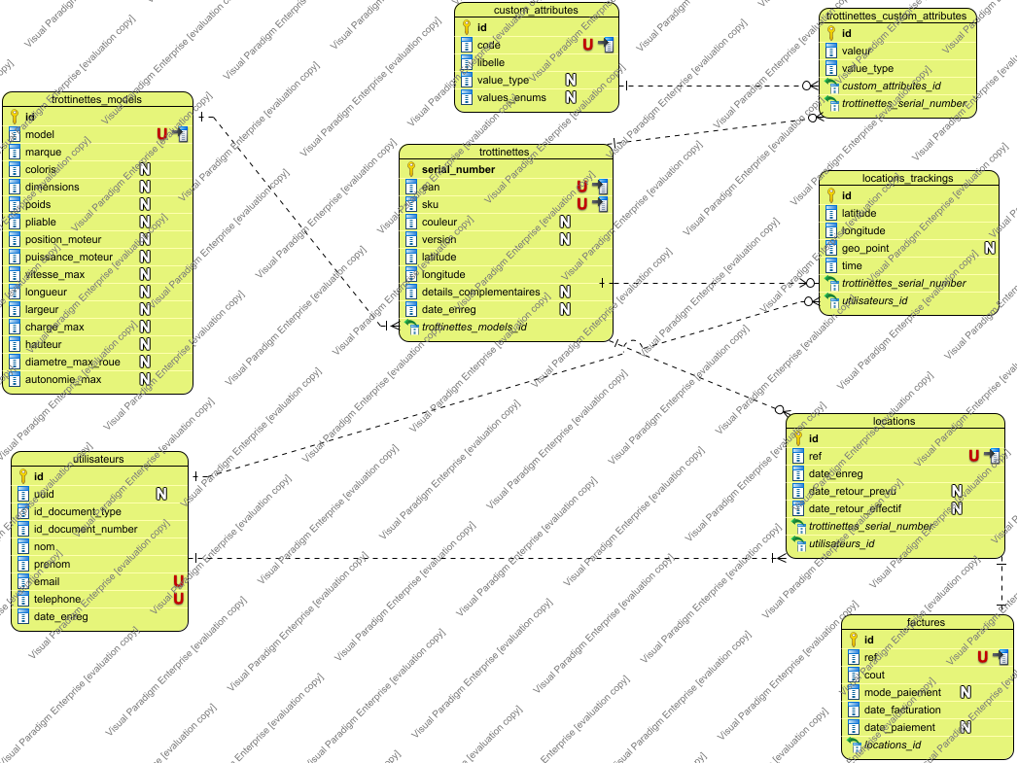

## Trottinettes - Entity Relationship Diagram - Modele Logique

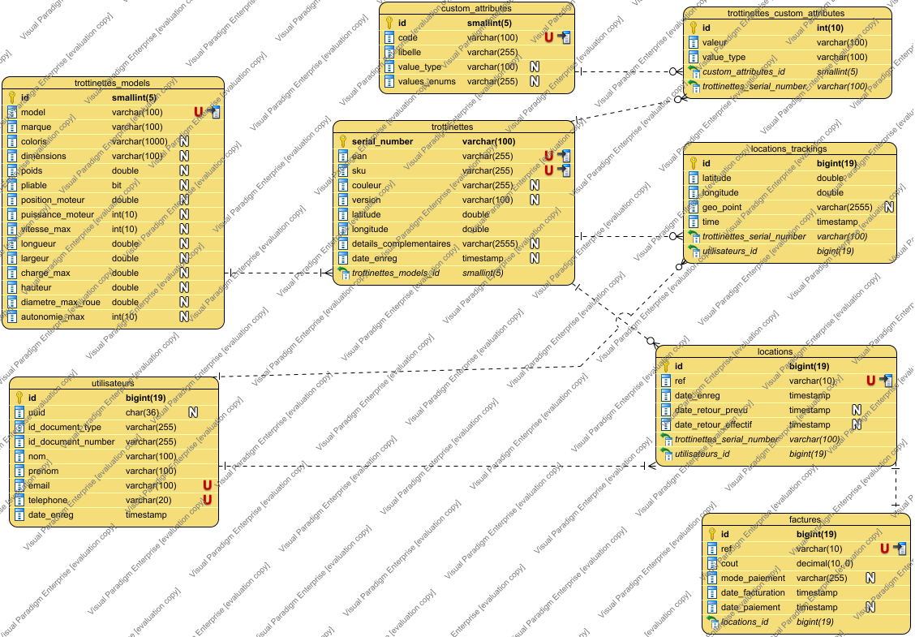

## Trottinettes - Entity Relationship Diagram - Modele Physique

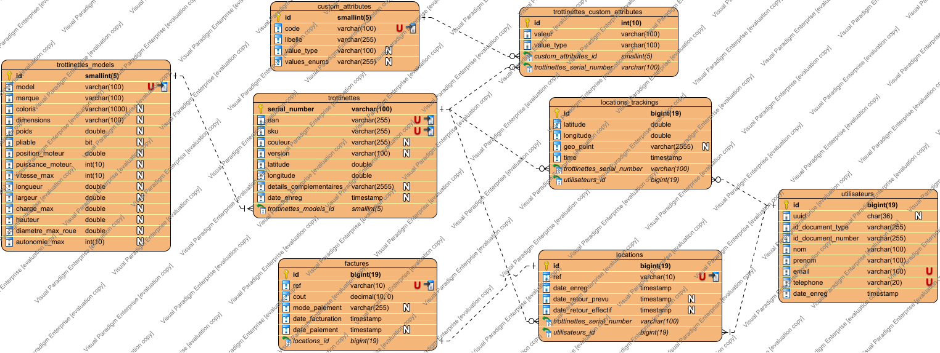

# Data Dictionary

## Data Dictionary

|  |  |  |  |  |  |  |  |  |  |
| --- | --- | --- | --- | --- | --- | --- | --- | --- | --- |
| Entity Name | Entity Description | |  |  |  |  |  |  |  | | --- | --- | --- | --- | --- | --- | --- | | Column Name | Column Description | Data Type | Length | Primary Key | Nullable | Unique | |
| custom_attributes |  | | code |  | varchar | 100 | false | false | true | | --- | --- | --- | --- | --- | --- | --- | | id |  | smallint | 5 | true | false | false | | libelle |  | varchar | 255 | false | false | false | | value_type |  | varchar | 100 | false | true | false | | values_enums |  | varchar | 255 | false | true | false | |
| factures |  | | cout |  | decimal | 10 | false | false | false | | --- | --- | --- | --- | --- | --- | --- | | date_facturation |  | timestamp | 0 | false | false | false | | date_paiement |  | timestamp | 0 | false | true | false | | id |  | bigint | 19 | true | false | false | | locations_id |  | bigint | 19 | false | false | false | | mode_paiement |  | varchar | 255 | false | true | false | | ref |  | varchar | 10 | false | false | true | |
| locations |  | | date_enreg |  | timestamp | 0 | false | false | false | | --- | --- | --- | --- | --- | --- | --- | | date_retour_effectif |  | timestamp | 0 | false | true | false | | date_retour_prevu |  | timestamp | 0 | false | true | false | | id |  | bigint | 19 | true | false | false | | ref |  | varchar | 10 | false | false | true | | trottinettes_serial_number |  | varchar | 100 | false | false | false | | utilisateurs_id |  | bigint | 19 | false | false | false | |
| locations_trackings |  | | geo_point |  | varchar | 2555 | false | true | false | | --- | --- | --- | --- | --- | --- | --- | | id |  | bigint | 19 | true | false | false | | latitude |  | double | 10 | false | false | false | | longitude |  | double | 10 | false | false | false | | time |  | timestamp | 0 | false | false | false | | trottinettes_serial_number |  | varchar | 100 | false | false | false | | utilisateurs_id |  | bigint | 19 | false | false | false | |
| trottinettes |  | | couleur |  | varchar | 255 | false | true | false | | --- | --- | --- | --- | --- | --- | --- | | date_enreg |  | timestamp | 0 | false | true | false | | details_complementaires |  | varchar | 2555 | false | true | false | | ean |  | varchar | 255 | false | false | true | | latitude |  | double | 10 | false | false | false | | longitude |  | double | 10 | false | false | false | | serial_number |  | varchar | 100 | true | false | false | | sku |  | varchar | 255 | false | false | true | | trottinettes_models_id |  | smallint | 5 | false | false | false | | version |  | varchar | 100 | false | true | false | |
| trottinettes_custom_attributes |  | | custom_attributes_id |  | smallint | 5 | false | false | false | | --- | --- | --- | --- | --- | --- | --- | | id |  | int | 10 | true | false | false | | trottinettes_serial_number |  | varchar | 100 | false | false | false | | valeur |  | varchar | 100 | false | false | false | | value_type |  | varchar | 100 | false | false | false | |
| trottinettes_models |  | | autonomie_max |  | int | 10 | false | true | false | | --- | --- | --- | --- | --- | --- | --- | | charge_max |  | double | 10 | false | true | false | | coloris |  | varchar | 1000 | false | true | false | | diametre_max_roue |  | double | 10 | false | true | false | | dimensions |  | varchar | 100 | false | true | false | | hauteur |  | double | 10 | false | true | false | | id |  | smallint | 5 | true | false | false | | largeur |  | double | 10 | false | true | false | | longueur |  | double | 10 | false | true | false | | marque |  | varchar | 100 | false | false | false | | model |  | varchar | 100 | false | false | true | | pliable |  | bit | 0 | false | true | false | | poids |  | double | 10 | false | true | false | | position_moteur |  | double | 10 | false | true | false | | puissance_moteur |  | int | 10 | false | true | false | | vitesse_max |  | int | 10 | false | true | false | |
| utilisateurs |  | | date_enreg |  | timestamp | 0 | false | false | false | | --- | --- | --- | --- | --- | --- | --- | | email |  | varchar | 100 | false | false | true | | id |  | bigint | 19 | true | false | false | | id_document_number |  | varchar | 255 | false | false | false | | id_document_type |  | varchar | 255 | false | false | false | | nom |  | varchar | 100 | false | false | false | | prenom |  | varchar | 100 | false | false | false | | telephone |  | varchar | 20 | false | false | true | | uuid |  | char | 36 | false | true | false | |

## Data Dictionary

|  |  |  |  |  |  |  |  |  |  |
| --- | --- | --- | --- | --- | --- | --- | --- | --- | --- |
| Entity Name | Entity Description | |  |  |  |  |  |  |  | | --- | --- | --- | --- | --- | --- | --- | | Column Name | Column Description | Data Type | Length | Primary Key | Nullable | Unique | |
| custom_attributes |  | | code |  | varchar | 100 | false | false | true | | --- | --- | --- | --- | --- | --- | --- | | id |  | smallint | 5 | true | false | false | | libelle |  | varchar | 255 | false | false | false | | value_type |  | varchar | 100 | false | true | false | | values_enums |  | varchar | 255 | false | true | false | |
| factures |  | | cout |  | decimal | 10 | false | false | false | | --- | --- | --- | --- | --- | --- | --- | | date_facturation |  | timestamp | 0 | false | false | false | | date_paiement |  | timestamp | 0 | false | true | false | | id |  | bigint | 19 | true | false | false | | locations_id |  | bigint | 19 | false | false | false | | mode_paiement |  | varchar | 255 | false | true | false | | ref |  | varchar | 10 | false | false | true | |
| locations |  | | date_enreg |  | timestamp | 0 | false | false | false | | --- | --- | --- | --- | --- | --- | --- | | date_retour_effectif |  | timestamp | 0 | false | true | false | | date_retour_prevu |  | timestamp | 0 | false | true | false | | id |  | bigint | 19 | true | false | false | | ref |  | varchar | 10 | false | false | true | | trottinettes_serial_number |  | varchar | 100 | false | false | false | | utilisateurs_id |  | bigint | 19 | false | false | false | |
| locations_trackings |  | | geo_point |  | varchar | 2555 | false | true | false | | --- | --- | --- | --- | --- | --- | --- | | id |  | bigint | 19 | true | false | false | | latitude |  | double | 10 | false | false | false | | longitude |  | double | 10 | false | false | false | | time |  | timestamp | 0 | false | false | false | | trottinettes_serial_number |  | varchar | 100 | false | false | false | | utilisateurs_id |  | bigint | 19 | false | false | false | |
| trottinettes |  | | couleur |  | varchar | 255 | false | true | false | | --- | --- | --- | --- | --- | --- | --- | | date_enreg |  | timestamp | 0 | false | true | false | | details_complementaires |  | varchar | 2555 | false | true | false | | ean |  | varchar | 255 | false | false | true | | latitude |  | double | 10 | false | false | false | | longitude |  | double | 10 | false | false | false | | serial_number |  | varchar | 100 | true | false | false | | sku |  | varchar | 255 | false | false | true | | trottinettes_models_id |  | smallint | 5 | false | false | false | | version |  | varchar | 100 | false | true | false | |
| trottinettes_custom_attributes |  | | custom_attributes_id |  | smallint | 5 | false | false | false | | --- | --- | --- | --- | --- | --- | --- | | id |  | int | 10 | true | false | false | | trottinettes_serial_number |  | varchar | 100 | false | false | false | | valeur |  | varchar | 100 | false | false | false | | value_type |  | varchar | 100 | false | false | false | |
| trottinettes_models |  | | autonomie_max |  | int | 10 | false | true | false | | --- | --- | --- | --- | --- | --- | --- | | charge_max |  | double | 10 | false | true | false | | coloris |  | varchar | 1000 | false | true | false | | diametre_max_roue |  | double | 10 | false | true | false | | dimensions |  | varchar | 100 | false | true | false | | hauteur |  | double | 10 | false | true | false | | id |  | smallint | 5 | true | false | false | | largeur |  | double | 10 | false | true | false | | longueur |  | double | 10 | false | true | false | | marque |  | varchar | 100 | false | false | false | | model |  | varchar | 100 | false | false | true | | pliable |  | bit | 0 | false | true | false | | poids |  | double | 10 | false | true | false | | position_moteur |  | double | 10 | false | true | false | | puissance_moteur |  | int | 10 | false | true | false | | vitesse_max |  | int | 10 | false | true | false | |
| utilisateurs |  | | date_enreg |  | timestamp | 0 | false | false | false | | --- | --- | --- | --- | --- | --- | --- | | email |  | varchar | 100 | false | false | true | | id |  | bigint | 19 | true | false | false | | id_document_number |  | varchar | 255 | false | false | false | | id_document_type |  | varchar | 255 | false | false | false | | nom |  | varchar | 100 | false | false | false | | prenom |  | varchar | 100 | false | false | false | | telephone |  | varchar | 20 | false | false | true | | uuid |  | char | 36 | false | true | false | |

## Data Dictionary

|  |  |  |  |  |  |  |  |  |  |
| --- | --- | --- | --- | --- | --- | --- | --- | --- | --- |
| Entity Name | Entity Description | |  |  |  |  |  |  |  | | --- | --- | --- | --- | --- | --- | --- | | Column Name | Column Description | Data Type | Length | Primary Key | Nullable | Unique | |
| custom_attributes |  | | code |  | varchar | 100 | false | false | true | | --- | --- | --- | --- | --- | --- | --- | | id |  | smallint | 5 | true | false | false | | libelle |  | varchar | 255 | false | false | false | | value_type |  | varchar | 100 | false | true | false | | values_enums |  | varchar | 255 | false | true | false | |
| factures |  | | cout |  | decimal | 10 | false | false | false | | --- | --- | --- | --- | --- | --- | --- | | date_facturation |  | timestamp | 0 | false | false | false | | date_paiement |  | timestamp | 0 | false | true | false | | id |  | bigint | 19 | true | false | false | | locations_id |  | bigint | 19 | false | false | false | | mode_paiement |  | varchar | 255 | false | true | false | | ref |  | varchar | 10 | false | false | true | |
| locations |  | | date_enreg |  | timestamp | 0 | false | false | false | | --- | --- | --- | --- | --- | --- | --- | | date_retour_effectif |  | timestamp | 0 | false | true | false | | date_retour_prevu |  | timestamp | 0 | false | true | false | | id |  | bigint | 19 | true | false | false | | ref |  | varchar | 10 | false | false | true | | trottinettes_serial_number |  | varchar | 100 | false | false | false | | utilisateurs_id |  | bigint | 19 | false | false | false | |
| locations_trackings |  | | geo_point |  | varchar | 2555 | false | true | false | | --- | --- | --- | --- | --- | --- | --- | | id |  | bigint | 19 | true | false | false | | latitude |  | double | 10 | false | false | false | | longitude |  | double | 10 | false | false | false | | time |  | timestamp | 0 | false | false | false | | trottinettes_serial_number |  | varchar | 100 | false | false | false | | utilisateurs_id |  | bigint | 19 | false | false | false | |
| trottinettes |  | | couleur |  | varchar | 255 | false | true | false | | --- | --- | --- | --- | --- | --- | --- | | date_enreg |  | timestamp | 0 | false | true | false | | details_complementaires |  | varchar | 2555 | false | true | false | | ean |  | varchar | 255 | false | false | true | | latitude |  | double | 10 | false | false | false | | longitude |  | double | 10 | false | false | false | | serial_number |  | varchar | 100 | true | false | false | | sku |  | varchar | 255 | false | false | true | | trottinettes_models_id |  | smallint | 5 | false | false | false | | version |  | varchar | 100 | false | true | false | |
| trottinettes_custom_attributes |  | | custom_attributes_id |  | smallint | 5 | false | false | false | | --- | --- | --- | --- | --- | --- | --- | | id |  | int | 10 | true | false | false | | trottinettes_serial_number |  | varchar | 100 | false | false | false | | valeur |  | varchar | 100 | false | false | false | | value_type |  | varchar | 100 | false | false | false | |
| trottinettes_models |  | | autonomie_max |  | int | 10 | false | true | false | | --- | --- | --- | --- | --- | --- | --- | | charge_max |  | double | 10 | false | true | false | | coloris |  | varchar | 1000 | false | true | false | | diametre_max_roue |  | double | 10 | false | true | false | | dimensions |  | varchar | 100 | false | true | false | | hauteur |  | double | 10 | false | true | false | | id |  | smallint | 5 | true | false | false | | largeur |  | double | 10 | false | true | false | | longueur |  | double | 10 | false | true | false | | marque |  | varchar | 100 | false | false | false | | model |  | varchar | 100 | false | false | true | | pliable |  | bit | 0 | false | true | false | | poids |  | double | 10 | false | true | false | | position_moteur |  | double | 10 | false | true | false | | puissance_moteur |  | int | 10 | false | true | false | | vitesse_max |  | int | 10 | false | true | false | |
| utilisateurs |  | | date_enreg |  | timestamp | 0 | false | false | false | | --- | --- | --- | --- | --- | --- | --- | | email |  | varchar | 100 | false | false | true | | id |  | bigint | 19 | true | false | false | | id_document_number |  | varchar | 255 | false | false | false | | id_document_type |  | varchar | 255 | false | false | false | | nom |  | varchar | 100 | false | false | false | | prenom |  | varchar | 100 | false | false | false | | telephone |  | varchar | 20 | false | false | true | | uuid |  | char | 36 | false | true | false | |

# Appendices